Baldivis Secondary College

Semester One Examination, 2016

Question/Answer Booklet

MATHEMATICS

SOLUTIONS
SPECIALIST
UNIT 1

Section One:

Calculator-free

Student Number: In figures

In words

Your name

Time allowed for this section
Reading time before commencing work: five minutes
Working time for section: fifty minutes

Materials required/recommended for this section
To be provided by the supervisor
This Question/Answer Booklet
Formula Sheet

To be provided by the candidate
Standard items: pens (blue/black preferred), pencils (including coloured), sharpener, correction fluid/tape, eraser, ruler, highlighters

Special items: nil

Important note to candidates
No other items may be taken into the examination room. It is your responsibility to ensure that you do not have any unauthorised notes or other items of a non-personal nature in the examination room. If you have any unauthorised material with you, hand it to the supervisor before reading any further.

Structure of this paper

Section | Number of questions available | Number of questions to be answered | Working  time (minutes) | Marks available | Percentage of exam
Section One:  Calculator-free | 7 | 7 | 50 | 49 | 35
Section Two:  Calculator-assumed | 13 | 13 | 100 | 102 | 65
 |  |  | Total | 151 | 100

Instructions to candidates

- The rules for the conduct of examinations are detailed in the school handbook. Sitting this examination implies that you agree to abide by these rules.

- Write your answers in this Question/Answer Booklet.

- You must be careful to confine your response to the specific question asked and to follow any instructions that are specified to a particular question.

- Spare pages are included at the end of this booklet. They can be used for planning your responses and/or as additional space if required to continue an answer.
- Planning: If you use the spare pages for planning, indicate this clearly at the top of the page.
- Continuing an answer: If you need to use the space to continue an answer, indicate in the original answer space where the answer is continued, i.e. give the page number. Fill in the number of the question that you are continuing to answer at the top of the page.

- Show all your working clearly. Your working should be in sufficient detail to allow your answers to be checked readily and for marks to be awarded for reasoning. Incorrect answers given without supporting reasoning cannot be allocated any marks. For any question or part question worth more than two marks, valid working or justification is required to receive full marks. If you repeat any question, ensure that you cancel the answer you do not wish to have marked.

- It is recommended that you do not use pencil, except in diagrams.

- The Formula Sheet is not to be handed in with your Question/Answer Booklet.

Section One: Calculator-free 35% (49 Marks)
This section has seven (7) questions. Answer all questions. Write your answers in the spaces provided.

Working time for this section is 50 minutes.

Question 1 (7 marks)
(a) Evaluate

(i) . (2 marks)
Solution
Specific behaviours
expands and cancels
simplifies

(ii) . (3 marks)
Solution
Specific behaviours
uses P and C notation correctly
cancels like factorials
simplifies answer

(b) Determine the values of a and b given (2 marks)
Solution
Specific behaviours
factors out 8! to obtain a
simplifies rest of expression to obtain b

Question 2 (8 marks)
Given and , determine

(a) . (1 mark)
Solution
Specific behaviours
determines vector

(b) . (1 mark)
Solution
Specific behaviours
determines vector

(c) . (2 marks)
Solution
Specific behaviours
determines vector
determine magnitude

(d) a unit vector in the same direction as . (2 marks)
Solution
Specific behaviours
determines magnitude of vector
determines unit vector

(e) the scalar projection of b onto . (2 marks)
Solution
Specific behaviours
uses scalar product
determines magnitude

Question 3 (7 marks)
(a) Prove that the opposite angles of a cyclic quadrilateral are supplementary. (4 marks)
Solution
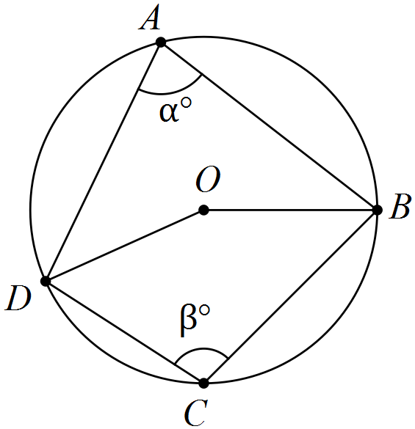
$∠DOB=2α$ (angle on arc $DCB$ at centre is twice angle on circumference)
$∠DOB=2β$ (angle on arc $DAB$ at centre is twice angle on circumference)
$2α+2β=360$ (angle sum of circle)
$α+β=180$ - opposite angles are supplementary
Specific behaviours
labelled diagram
uses angle at centre twice circumference
uses angle sum at centre
completes proof

(b) Determine, with reasons, the size of in the diagram below. (3 marks)

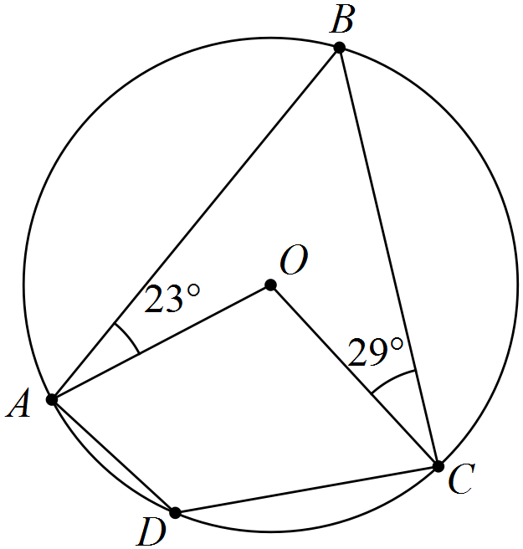
Solution
Specific behaviours
uses isosceles triangles
determines
determines with reason

Question 4 (7 marks)
Consider the vectors , and .

(a) Determine the vector projection of a onto b. (3 marks)
Solution
Specific behaviours
calculates scalar product
calculates magnitude of b
determines vector

(b) Express c in the form . (4 marks)
Solution
Specific behaviours
writes simultaneous equations
eliminates one variable and solves
solves for other variable
writes in required form

Question 5 (8 marks)
(a) An equilateral triangle of side 2a circumscribes a circle, as shown in the diagram below. Express the exact radius of the circle in terms of a. (4 marks)

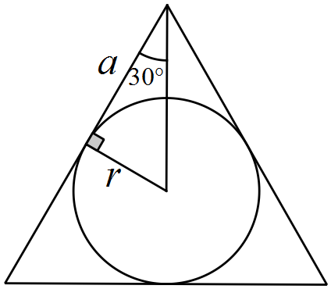

Solution
Specific behaviours
draws right triangle using tangent and radius
places angle and variables on diagram
determines relationship between r and a
expresses r in terms of a

(b) Two circles touch internally at B, as shown below. AB, AC and AD are tangents, and . Determine, with reasons, the size of . (4 marks)

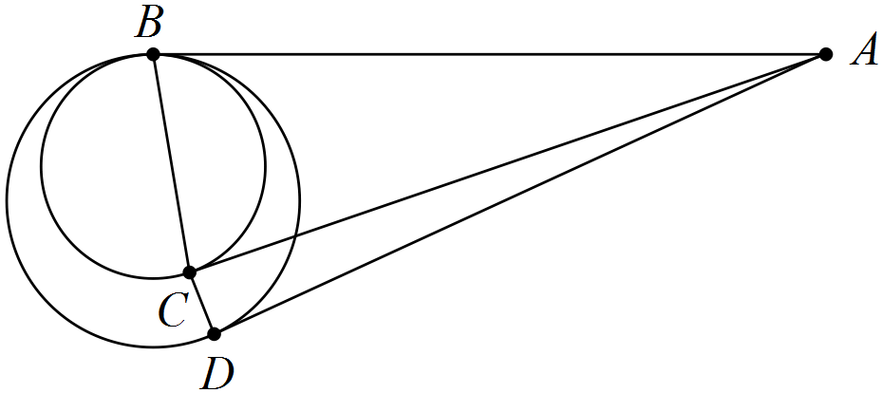
Solution
As B is common to both circles, then as tangents from external point, and . Hence triangles ABC and ACD are both isosceles.

Specific behaviours
explains why
determines
determines
determines

Question 6 (6 marks)
OABC is a trapezium with . M lies on the diagonal OB so that and N lies on the diagonal CA so that . Let and .

By determining a vector for MN, or otherwise, prove that ABNM is a parallelogram.
Solution
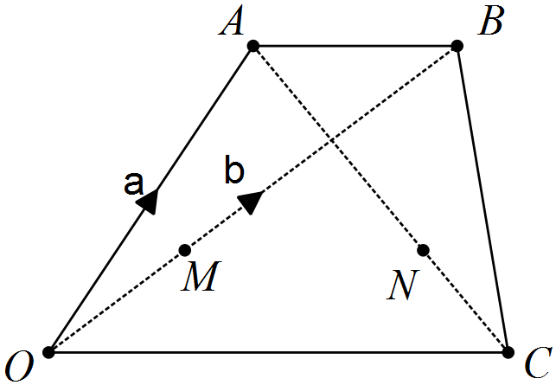

Hence ABNM is a parallelogram, as it has a pair of opposite sides that are parallel and congruent.
Specific behaviours
draws diagram
determines OM in terms of b
determines ON in terms of other vectors
determines ON in terms of a and b
determines MN in terms of a and b
shows MN=AB and concludes proof with reasons

Question 7 (6 marks)
(a) Show that when but not when . (2 marks)
Solution
Specific behaviours
clearly demonstrates first case is true
demonstrates second case is false

(b) Prove by contradiction that, for every positive real number x, . (5 marks)
Solution
Assume there exists a positive real number x such that .

Since , then and , and so inequality can be multiplied by without reversing inequality direction.

Hence

This results in the contradiction that and so we must conclude that no such positive real number x exists so that , hence proving that.

Specific behaviours
writes contra of proof
cross multiplies
notes no need to reverse inequality
simplifies inequality
makes conclusion

Additional working space

Question number: _________

Additional working space

Question number: _________

© 2016 WA Exam Papers. Baldivis Secondary College has a non-exclusive licence to copy and communicate this paper for non-commercial, educational use within the school. No other copying, communication or use is permitted without the express written permission of WA Exam Papers.

